User Manual - PantryRaid Group E

Aman Mehta,

Nam Nguyen,

Kan Yamamoto,

Randy Nguyen,

Nasser Alsuhaimi,

James Blancaflor,

Benjamin Guerrero

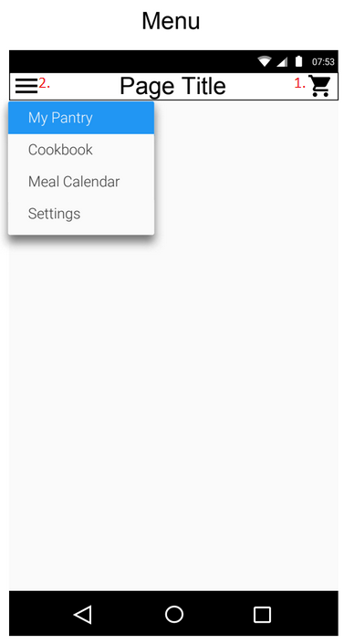

To go to checkout:

Step 1: press the image with the number 1.

To Navigate to through different pages:

Step 1: Press the icon near the number 2.

Step 2: Click on any of the options to navigate to that page.

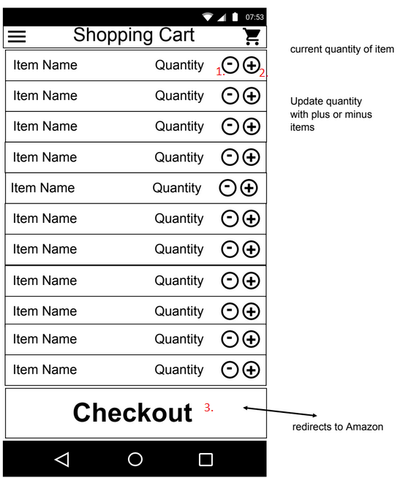

Adding quantity of ingredient

Step 1: Press Button 1

Lowering quantity of ingredient:

Step 1: Press button 2

Checking ingredients out:

Step 1: Press button 3

Step 2: click the “done” button

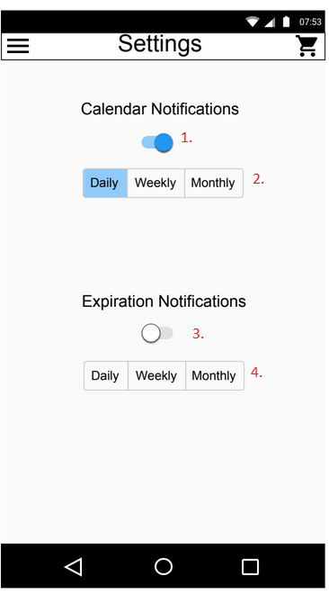

Turning On Or Off Calendar Notifications:

Step 1: Click on switch near number 1. If the ball is to the right, notifications are on. To turn off click on it again.

Changing The Calendar View

Step 1: Click on either Daily, Weekly, or Monthly to change how you want your calendar to view your calendar.

Turning On Or Off Expiration Notifications

Step 1: Click the switch near the number 3. If the ball is to the right, notifications are on. To turn off click on it again.

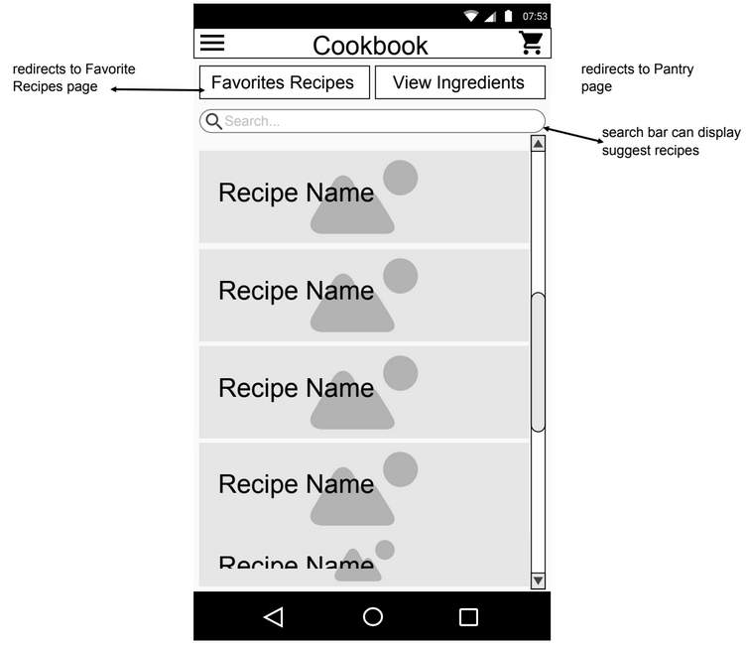

To Access Favorite Recipes:

Step 1: Go to Cookbook page

Step 2: Click on Favorite Recipes

To View Ingredients You Have

Step 1: Go to Cookbook page

Step 2: Click on View Ingredients

Or:

Step 1: Click on the icon near the number 4.

Step 2: From the menu options, click on **My Pantry**.

To Search for Recipes:

Step 1: Go to Cookbook page

Step 2: On the search bar with the number 3, type in any recipe you wish to make.

Step 4: Click on any of the recipes from the drop down menu.

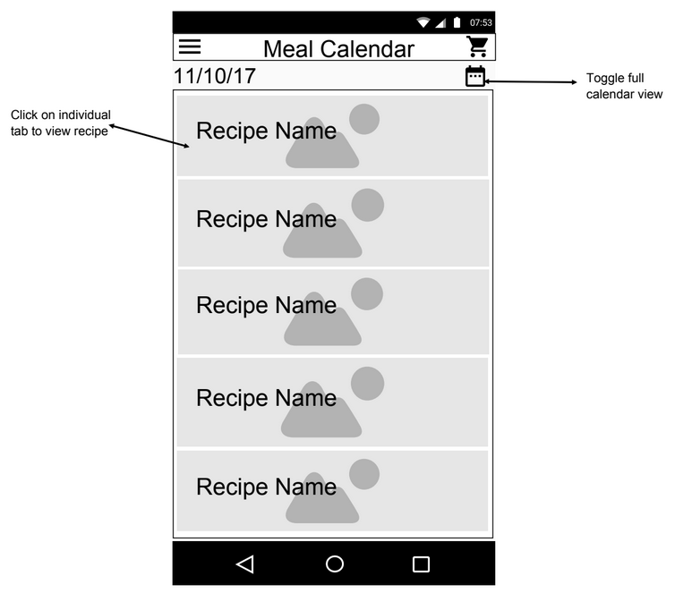

To View Individual Recipes

Step 1: Tap on desired recipe.

To Toggle Calendar View

Step 1: Tap on the calendar icon in the top right corner.

Adding A Recipe to Meal Calendar: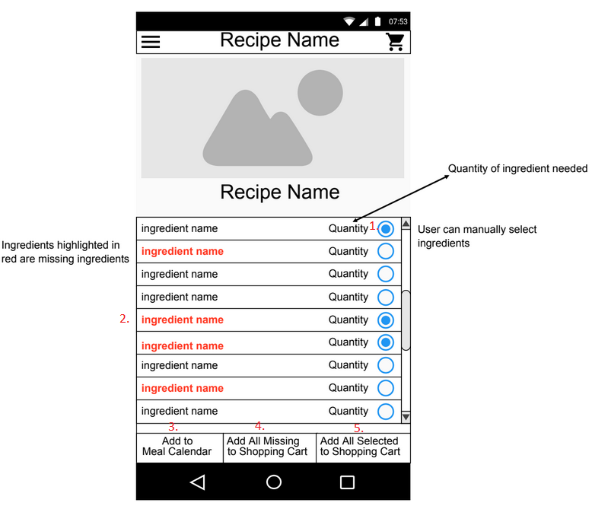

Step 1: Confirm displayed recipe is the desired recipe.

Step 2: Click on “Add to Meal Calendar”.  
Step 3: Choose date to add meal to.

Adding Missing Recipe Items To Shopping Cart  
Step 1: Click on “Add All Missing to Shopping Cart”.

Adding Individual Missing Recipe Items to Shopping Cart:

Step 1: Manually select and indicate quantity of wanted ingredients using the buttons on the right.  
Step 2: Click on “Add All Selected to Shopping Cart”.

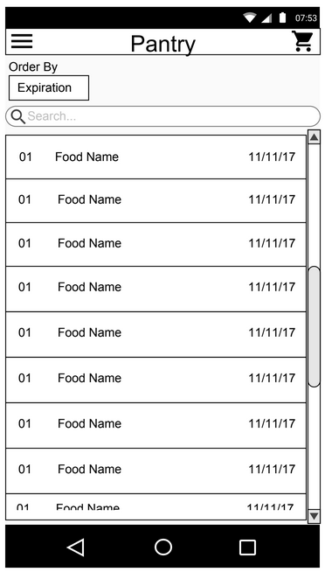

Searching for Items in the Pantry  
Step 1: Tap on the search bar

Step 2: Enter name of item you want to search for.

Adding items in the Pantry:

Step 1: Tap on the search bar.

Step 2: Enter name of item you want to add for.

Step 3: click on the plus button.

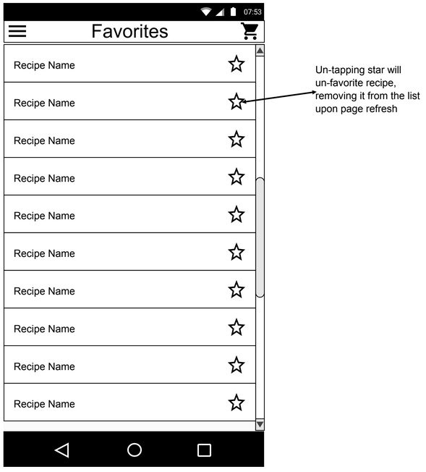

Unfavoriting a Recipe

Step 1: Tap the star of the recipe you want to unfavorite such that it is no longer colored.

Step 2: Refresh the favorites page to confirm.